**1．官网下载jdk安装包**

<http://www.oracle.com/technetwork/java/javase/downloads/jdk8-downloads-2133151.html>

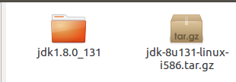

**2.将下好的jdk-8u131-linux-i586.tar.gz移动到DownLoads，并且解压**

tar -xf jdk-8u131-linux-i586.tar.gz

**3.将压缩好的文件移动到 /usr/lib/jvm/**

sudo mv Downloads/jdk1.8.0_131 /usr/lib/jvm/

**4.配置全局变量**

1）呼叫出配置环境变量的文件

gedit ~/.bashrc

2）

export JAVA_HOME=/usr/lib/jvm/jdk1.8.0_151

export JRE_HOME=${JAVA_HOME}/jre

export CLASSPATH=.:${JAVA_HOME}/lib:${JRE_HOME}/lib

export PATH=${JAVA_HOME}/bin:$PATH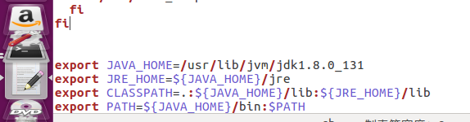

source ~/.bashrc

java -version